Design History File: JIASize - Laryngeal Sizing Device
Isabella Koshoffer, Alex Madzia, Jocelyn Masters
March 24, 2022
Table of Contents
Clinical Background 4
User Research 5
User Needs 7
Competitive Analysis & Predicate Devices 13
Initial Concepts & Concept Select-Down 20
Concept Select Down Part 2: Internal Mechanism 22
Product Requirements Specification 34
Engineering Calculations 42
Detailed Engineering Drawings 50
Bill of Materials 63
V&V Plan Traceability Matrix 65

Clinical Background
The airway is defined as the organs that allow airflow into the lungs. A basic overview of the anatomy of the airway is that the airway starts at the nose and oral cavity then continues down to the pharynx, and then the epiglottis, into the larynx, down into the trachea, and then into the lungs.
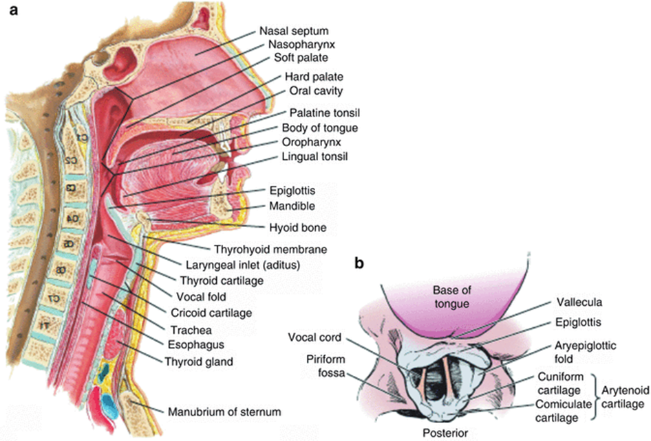
Figure 1: Airway Anatomy
https://www.rejuvdentist.com/sleep-apnea/airway-anatomy/

The airway is separated into two regions: the upper and lower airways, which are separated by the epiglottis. The epiglottis is a leaf shaped piece of cartilage at the base of the tongue which prevents food from entering the airway. The lower airway is divided into supraglottic and subglottic regions. The glottis is the narrowest part of the larynx which sits on the floor of the pharynx. 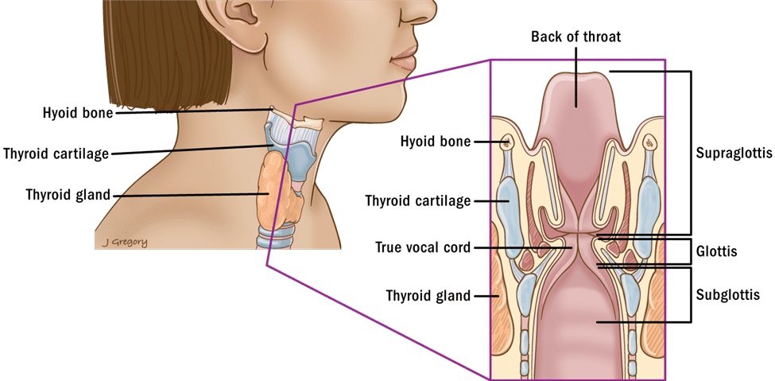
Figure 2: Lower Airway Anatomy
https://thancguide.org/cancer-types/throat/laryngeal/glottic/anatomy/
Airway stenosis is a narrowing of the airway that prevents the passage of air into the lungs. Airway stenosis can occur for several reasons including congenital conditions, cancer, external injury, or some autoimmune disorders. The symptoms of airway stenosis include coughing, wheezing, labored breathing, and cyanosis (a bluish color of the skin or mucus membranes) (Riley Children’s Health). Airway stenosis is a rare disease, it only occurs in one out of four hundred thousand people. However, in pediatric patients, subglottic airway stenosis can be fatal since a pediatric subglottic diameter is about four millimeters (Mayo Clinic, 2019).
Airway stenosis is diagnosed by x-ray, computed tomography (CT) scans, laryngoscopy, or bronchoscopy. Imaging is a useful tool for diagnosis but is not accurate enough to determine the surgical tools needed. Imaging is done to diagnose the patient and determine the relative size and shape of the stenosis and then a laryngeal sizing device is used immediately before surgery to check the size of the airway and then also after surgery to check the size of the intervention. Though this method is more invasive and can potentially cause further inflammation, the diameter of the airway is important to know for treatment. The airway size can change from the time of imaging to surgery. The airway size will also affect the amount of anesthesia needed (A. Jain, personal communication, March 24th, 2022). Airway stenosis is treated with surgery either by placing a stent to keep the airway open or by cutting away the obstruction (Cotton & Smith, 2018). The airway size is important to know for surgical planning because it drives which operating tools are chosen (A. Jain, personal communication, March 24th, 2022).

User Research
To inform the user needs, the team performed user research. An interview was conducted with Aseem Jain, a medical resident at the University of Cincinnati. The interview was conducted through email. According to Aseem

Revision | Description | Author | Date
0 | Initial Release | Isabella Koshoffer | 3/22/2022
1 | Design Review 1 | Isabella Koshoffer | 4/21/2022

REQUIRED | APPROVALS | DATE
Position Title | Signature
Author | Isabella Koshoffer | 4/21/2022
Quality Manager | Isabella Koshoffer | 4/21/2022

User Needs

- Revision History
Revision | Description | Author | Date
0 | Initial Release | Jocelyn Masters | 04/01/2022
1 | Updates to User Needs. | Jocelyn Masters | 4/20/2022

- Approvals
Representative | Signature | Date
Author/Jocelyn Masters | Jocelyn Masters | 4/21/2022
Quality Manager/Jocelyn Masters | Jocelyn Masters | 4/21/2022

- PURPOSE
This document’s purpose is to define the User Needs of the JIASize.

- SCOPE
The User Needs for the JIASize are included in this document.

- APPLICABLE STANDARDS
- List any standards or best practices that were referenced for the development of this document.
- PRODUCT DESCRIPTION
The desired device will be used to provide an accurate measurement of the pediatric patient’s airway stenosis to the surgical team. This information is vital in the planning of the surgery and the use of tools during the procedure. The diameter of a pediatric trachea is usually around 4 millimeters (about 0.16 in). This small diameter, with a stenosis making this even smaller, requires a device that is small enough to fit in the airway without damaging the surrounding tissue.
- ENVIRONMENT DESCRIPTION
  - Physical environment
- Operating Room (OR)
Description | An operating room is the environment where a surgical team performs a variety of procedures. It is a clean, aseptic, and controlled room. The room often contains lots of equipment, key pieces being the operating table and the anesthesia cart. Outside of the operating area is a designated scrubbing area used by personnel who will be in the surgery.
Conditions | - Lighting: the operating room and table are well lit by overhead surgical lights to allow the surgeon to see into the local area or cavity of the patient  - Temperature: most operating rooms are kept below 73.4 degrees Fahrenheit, to keep surgeons and the surgical staff cool. Thus, patients are heated using blankets to prevent heat loss and hypothermia while under anesthesia.  - Set up: the anesthesia cart is kept close to the operating table, and different monitors are placed throughout the room to always keep the patient’s vital signs visible.
Use Cases | Most operations using anesthesia require an operating room environment. This is the safest space for the patient to have procedures done as the environment is aseptic and sterilized and contains all the necessary equipment within reach.

  - User
- Surgeon
Description | Responsible for: Performing the sizing of the airway prior to the surgical procedure. This determines what tooling and methods will be used to treat airway stenosis in the pediatric patient.
Knowledge and Education | Medical school; expertise in laryngeal procedures
Use Scenario Role | Responsible for: taking a preoperative measurement of the pediatric airway to determine the grade and severity of the present airway stenosis. Device is crucial in the planning of the surgery once measurement is taken by surgical team.
Work Environment | Operating Room

- USER NEEDS
  - Primary System Functionality
ID | SOURCE | User Need
UN 1 | Surgeons must measure the diameter of airway stenosis in pediatric patients prior to surgery. | Users need a way to safely measure the diameter of airway stenosis.
UN 2 | A handheld device is used to measure the pediatric airway prior to surgery. | Users need a comfortable, handheld device that fits a range of surgeons’ hand sizes.
UN 3 | A simple device is desired to make the measurement process quick and efficient. | User needs a device that is simple and quickly measures the airway stenosis to streamline the procedure preparation.
UN 4 | The device needs to prevent further damage and inflammation to the patient’s trachea during the measurement process. | Users need a device that can be used in conjunction with a camera to enable a visual on the device’s location in the trachea to prevent further tissue damage.

  - Physical Design of Controlling Box
ID | SOURCE | User Need
UN 5 | Pediatric subglottic diameters are around 4mm (about 0.16 in) in diameter, and airway stenosis decreases this diameter. | Users need a small device that can be used to measure a range of stenosis severity grades in pediatric patients.
UN 6 | Accurate measurements of airway stenosis determine the path of the surgical procedures and tools used. | Users need a device that is calibrated to give accurate measurements of the airway stenosis severity.

  - Graphic User Interface
ID | SOURCE | User Need
UN 7 | Users do not have time to read a small ruler accurately through a camera in the patient’s airway. | Users need a visual indication on the device to display the measurement of the airway stenosis once measured by the device.

FORM REVISION HISTORY
REV | AUTHOR NAME | REVISION DESCRIPTION | REVISION DATE
0 | Jocelyn Masters | Initial Release | 04/01/2022
1 | Jocelyn Masters | Design Review 1 | 04/21/2022

REQUIRED | APPROVALS | DATE
Position Title | Signature
Author/ | Jocelyn Masters | 04/04/2022
Quality Manager | Jocelyn Masters | 04/21/2022

Competitive Analysis & Predicate Devices
1. REVISION HISTORY
FORM REVISION HISTORY
REV | AUTHOR NAME | REVISION DESCRIPTION | REVISION DATE  (DD-MMM-YYYY)
0 | Jocelyn Masters, Alex Madzia | Initial Release | 4/4/2022
1 | Jocelyn Masters, Alex Madzia | Design Review 1 | 4/21/2022

2. APPROVALS
REQUIRED | APPROVALS | DATE
Position Title | Signature
Author/ | Jocelyn Masters  Alex Madzia | 4/4/2022
Quality Manager | Jocelyn Masters | 4/21/2022

3. PURPOSE
This document’s purpose is to describe predicate devices of JIASize and the competitive landscape of the airway sizing market.
4. SCOPE
The Competitive Analysis and Benchmarking for the JIASize are included in this document.
5. COMPETITIVE ANALYSIS
5a. Current Standard of Treatment
Approach 1: Myer-Cotton Method
Description: An endotracheal tube such as the one shown in Figure X with the smallest possible diameter is inserted into the intubated patient’s mouth under anesthesia and manually advanced until the cuff is in the stenotic portion of the airway. The cuff is then inflated to 20 cm H₂O, and a leak test is performed. To perform the leak test, the physician listens for the sound of air. If air is heard, the ET tube is removed, and an ET tube of a slightly larger diameter is inserted. These steps are repeated until an ET tube is inserted and no air is heard. This method can require up to five different diameter ET tubes before the correct size is determined.
Financial Analysis:
Endotracheal Intubation CPT code: 31500
Reimbursement: $149.41
https://www.aana.com/docs/default-source/practice-aana-com-web-documents-(all)/20200402-crna-reimbursement-for-critical-care-services.pdf?sfvrsn=19977ca7_8

Laryngoscopy Direct, with or without Tracheoscopy CPT code: 31528
Reimbursement: $635.65
http://www.medpricemonkey.com/cpt_code?cpt_code=31528

Figure 5.1
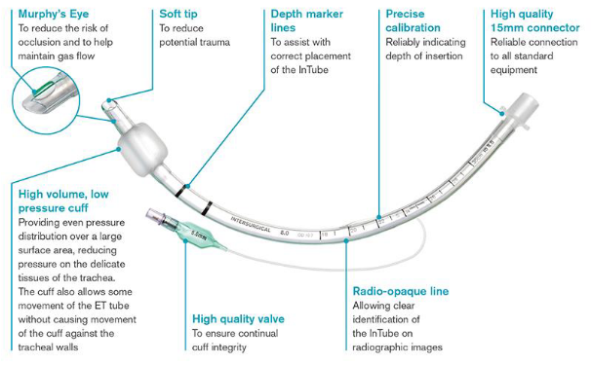

Figure 5.2
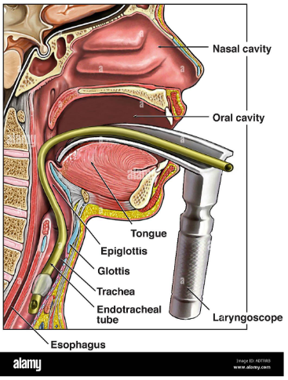

Approach 2: Bent Kirschner Wires
A second approach discovered was simple in design, using a Kirschner wire with the end bent at a 90-degree angle. Different sizes of the wires were made, with the ends measured and calibrated to a certain length. These lengths of wire were inserted into the trachea using a laryngoscope to visualize the stenosis and wire position. The wires could be quickly interchanged to find the correct measurement of the airway stenosis. This method has been investigated in clinical research settings but is not an FDA-approved device for this application. The cost of the set of five wires was about $17.

Figures 5.3a and 5.3b
a.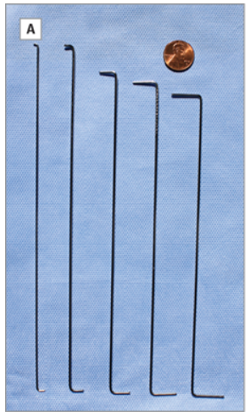b. 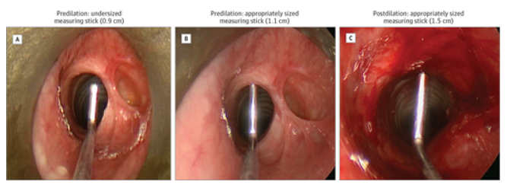
https://jamanetwork.com/journals/jamaotolaryngology/fullarticle/2119040

Approach 3: Ultrasonography
A non-invasive imaging approach to airway sizing also exists. This method involves the patient lying on their back with their neck extended. A physician places a linear ultrasound probe on the cricoid cartilage, and once the proper view is obtained, records the subglottic diameter measurement (dashed blue line). This method has been the subject of multiple publications. One drawback of this approach is that it requires an ultrasound machine, which may not be present in the operating room at the time of the procedure. Therefore, this measurement may have to be taken at a pre-surgical visit, and the airway may change in size between this initial measurement and the time of the procedure.
Financial Analysis:
Ultrasound, Soft Tissues of Head and Neck, Real Time with Image Documentation CPT Code: 76536
Reimbursement: $114.46
https://www.gehealthcare.com/-/jssmedia/global/products/images/ultrasound/primary-care/pc-reimbursement-advisory_v2-jb59698us.pdf?rev=-1&hash=07AA3B817FEE780C7E8FECB6958DC403

Figure 5.4
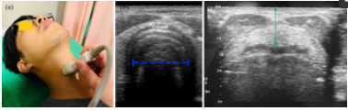
6.0 Predicate Device:
The JiaSize airway sizing device will be submitted to the FDA through the 510(k) submission process, using Covidien’s SealGuard Endotracheal Tube (Figure 6.1) as the predicate device. This device was chosen because like JiaSize, it consists of a flexible plastic tube that is inserted through the mouth into the subglottic region of the airway. Therefore, similar anatomical and physiological considerations, material properties, and dimensions must be considered.
Figure 6.1
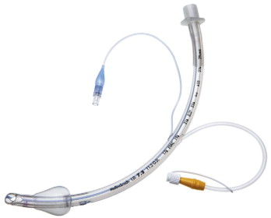

7.0 SWOT Analysis
 | Internal | External
Positive | Strength  -Simplicity (no digital or electrical components)  -Shaft narrower than airway to mitigate abrasion that could worsen stenosis | Opportunity  -Sustainability concerns (Myer-Cotton method uses several disposable plastic ET tubes, JIASize uses one device per patient)  -Mechanism of expanding jaws has potential to be used in other anatomical regions (esophagus, colon, blood vessels)
Negative | Weakness  -Requires concurrent use with endotracheal camera  -Jaws could be hazardous to tissue | Threats  -Lack of similar predicate device could complicate approval pathway  -Potential for reusable device to be invented that could make JIASize obsolete

The SWOT analysis showed that despite the opportunity for further innovations, JIASize fulfills its needs more effectively than the current standard of treatment and has the potential to use its measurement mechanism for other procedures.

Initial Concepts & Concept Select-Down

Concept Select Down Part 1: Initial Designs

- Claw Machine Concept
  - 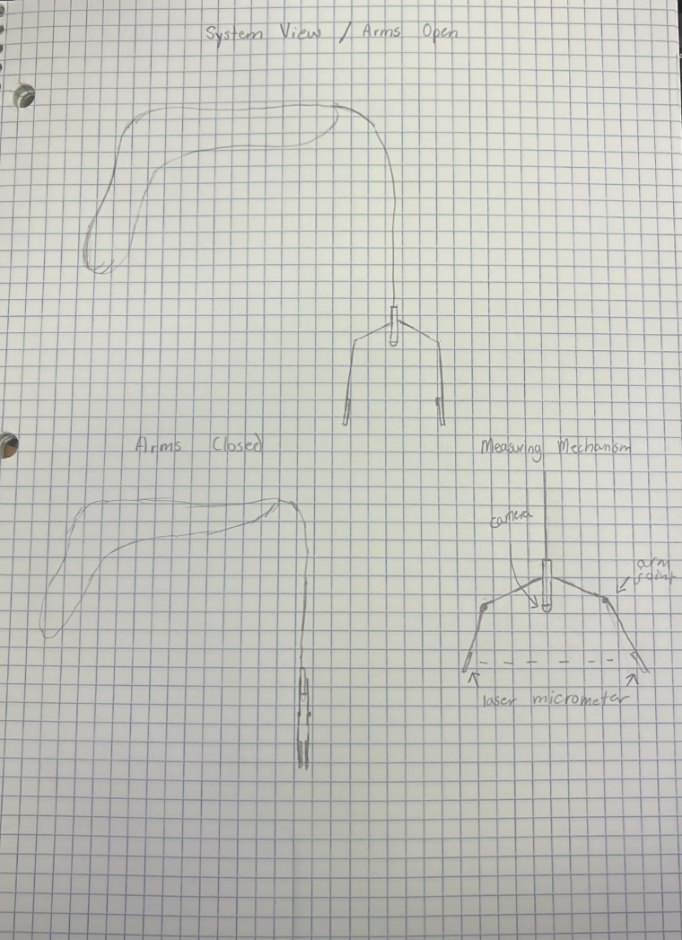
  - When the device is “off” the hands of the device are closed so that the user can insert the device without contact with the walls of the trachea. The user will turn a dial at the top of the device causing the hands of the device to open. The distance between the hands will measure the size of stenosis.
  - Advantages: Collapsible so the device can be safely inserted and removed
  - Disadvantages: Small intricate parts
- Overlapping Strainer Concept
  - 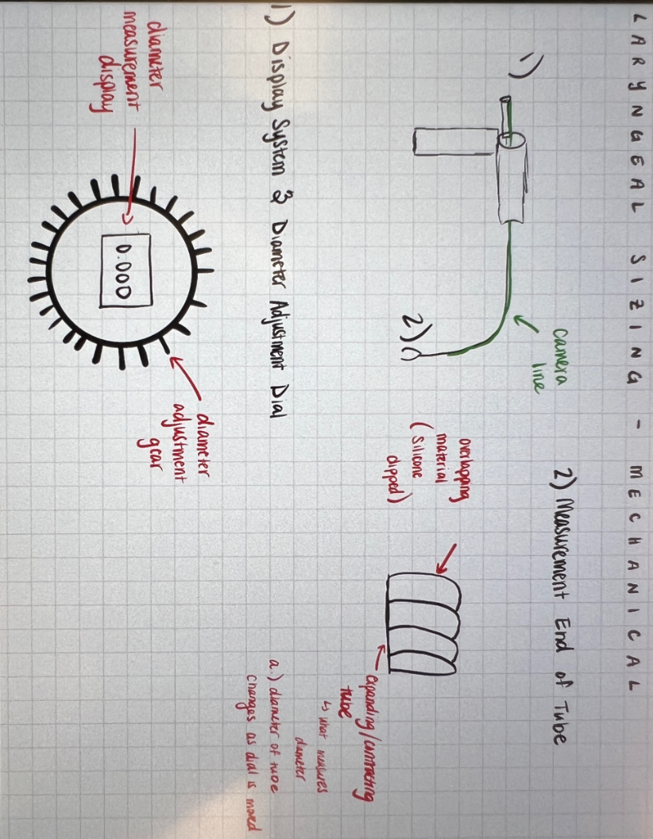
  - The overlapping pieces of material open similarly to a strainer basket. The diameter of the circle made by the end of the device will measure the stenosis.
  - Advantages: Collapsible
  - Disadvantages: Intricate parts and spaces that could store bacteria
- Rotating Laser Concept
  - 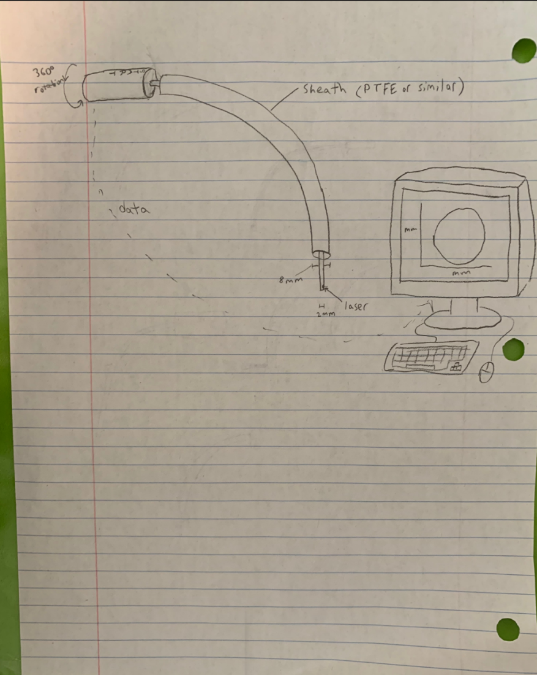
  - A Plastic tube will be inserted into the throat. A wire with a rotating laser will be inserted through the tube. The laser will rotate 360 degrees and measure the throat by measuring the time that it takes for the light to bounce back.
  - Advantages: Reusable, Thin (Safe for insertion and removal)
  - Disadvantages: Lasers make for difficult clinical trials, could cause damage (A. Jain, personal communication, March 24th, 2022).

Concept Select Down Part 2: Internal Mechanism
- Spring with internal tension wire
  - 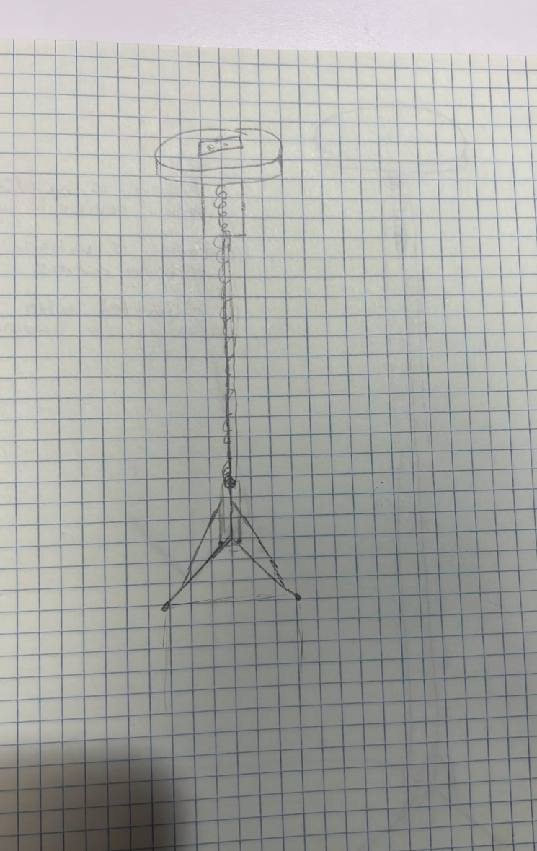
  - Description: Spring capsule with wire running through the interior wire attached to the dial and to the arms of the device. Turning the dial pulls the arms up. The distance between the hands of the device measures the diameter of the airway.
  - Advantage: Cheap materials
  - Disadvantage: Spring negatively impacts function by adding additional tension to the internal wire
- Plastic Tube with internal tension wire
  - 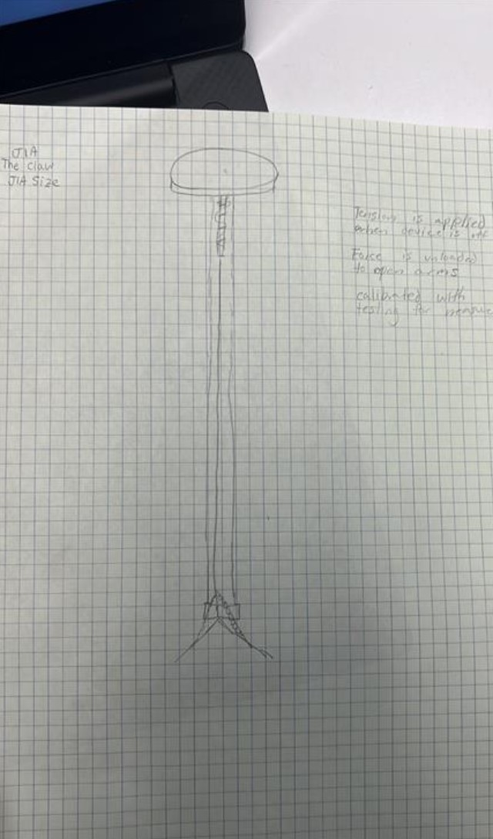
  - Description: Flexible plastic tube with wire in the interior, wire attached to the dial. When the dial is turned the wire coils around it. Wire connected to the arms of the device
  - Advantages: Cheap materials
  - Disadvantages: Tube negatively impacts function by adding additional tension to the internal wire
- Interlocking Gears
  - 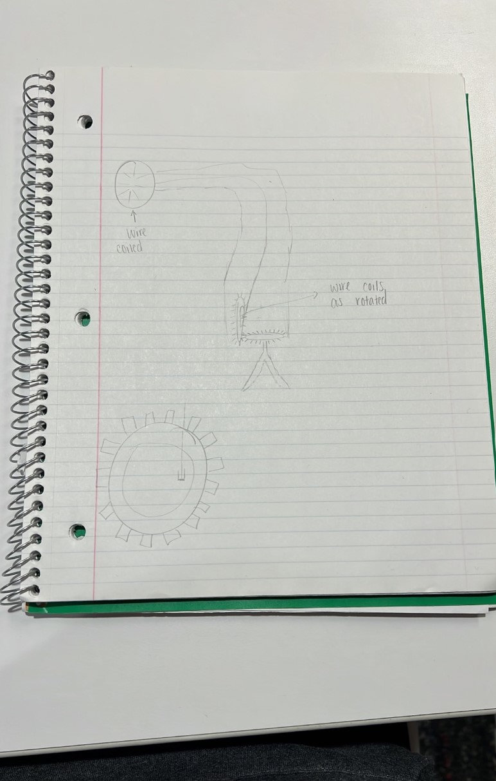
  - Description: Turning gears opens arms, wire coils as gear turns
  - Advantages: Mechanical strength
  - Disadvantages: expensive
- Wire advancement
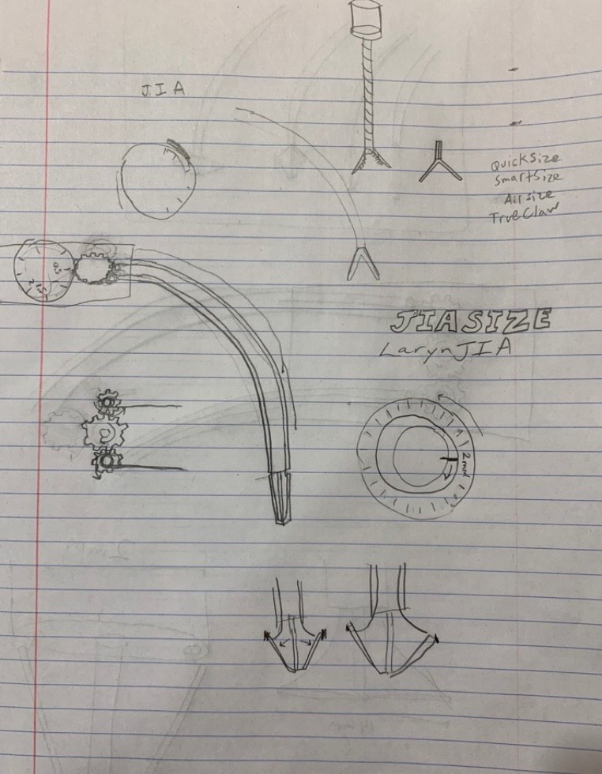
  - Description: Gears turn to release wires. Wires attach to the tips of the arms and release the arms when the wires increase in length.
  - Advantages: functional, gears are mechanically strong
  - Disadvantages: sterilization is complicated, could create a prong that can get caught in tissue
- Collapsible Circle
  - 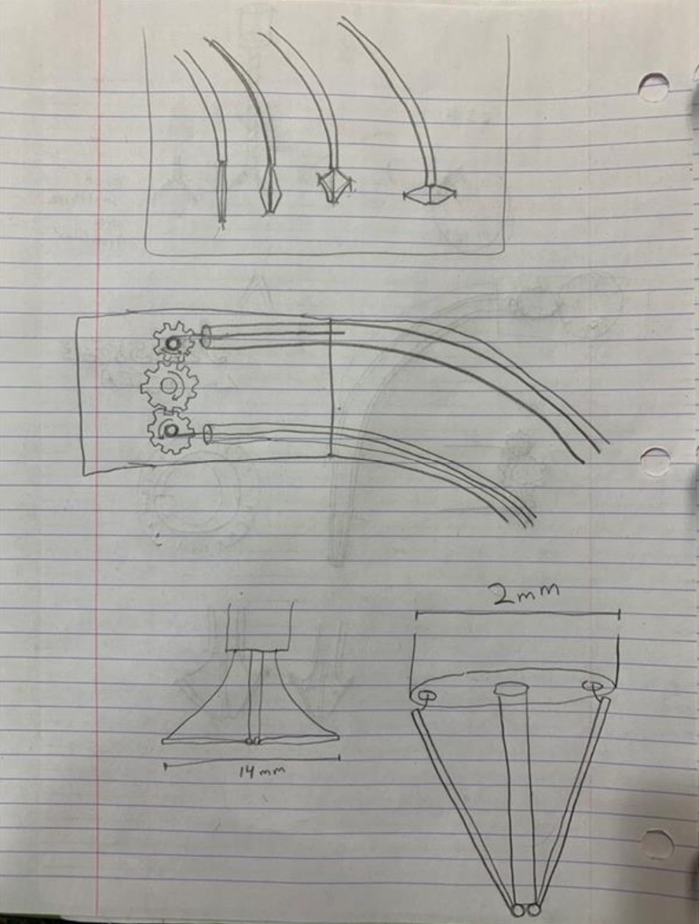
  - Description: Flexible, collapsible sphere compresses into flat disk, largest cross section diameter measures airway size
  - Advantages: No sharp edges, safest concept
  - Disadvantages: Complicated Manufacturing
- Coiled Wire
  - 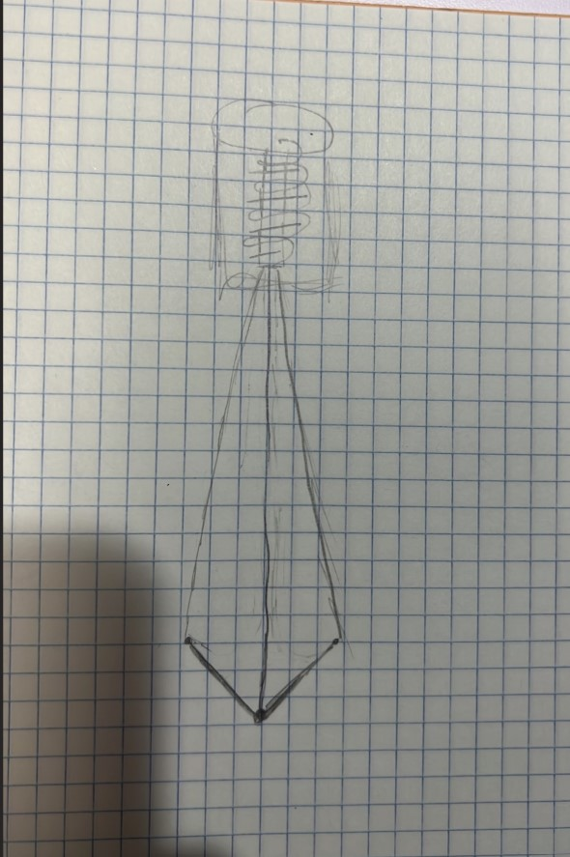
  - Description: Two wires attached to dial. Central flexible wire for mechanical strength. Turning dial releases wires opening the arms. Distance between tips of arms measures diameter of airway.
  - Advantages: Simple materials, cost effective
  - Disadvantages: Coil of wire is susceptible to wear, and the two wires can tangle.
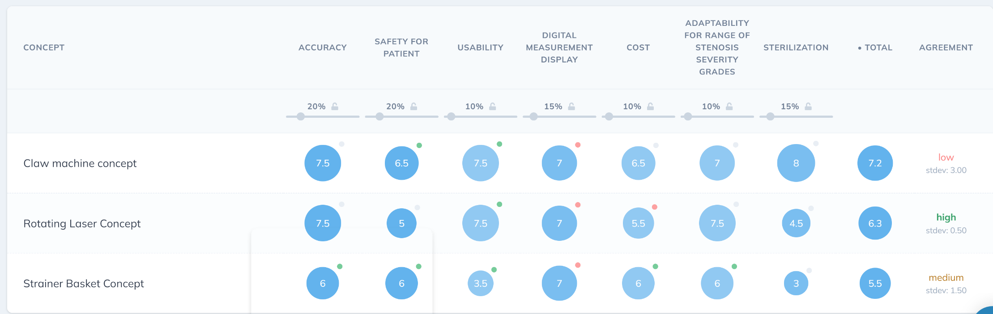Table 1: Initial Concepts Concept Select Down
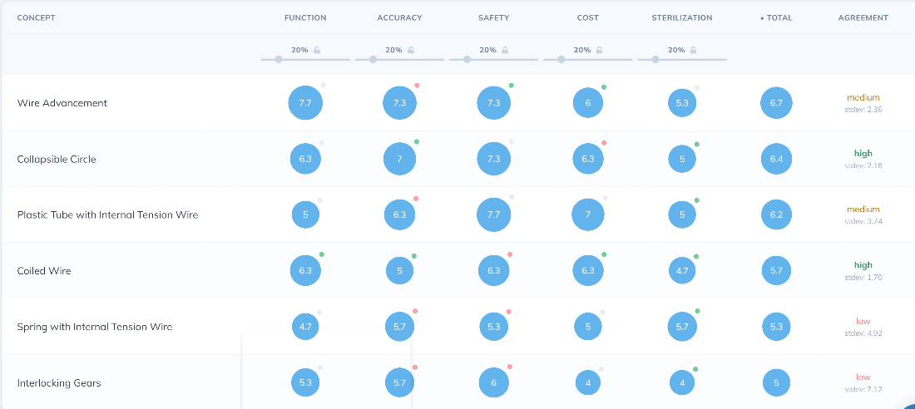
Table 2: Internal Mechanism Concept Select Down
Based on the concept select down, the claw concept with the wire advancement internal mechanism was chosen (Concept 4). This design was chosen because of its functionality and safety. This design would be able to collapse for safe removal from the airway and the geometry of the design makes it optimal for sterilization. The design will make minimal contact with the tissue in the airway to minimize damage during measurement.
Figure 1 – Selected Concept CAD Model
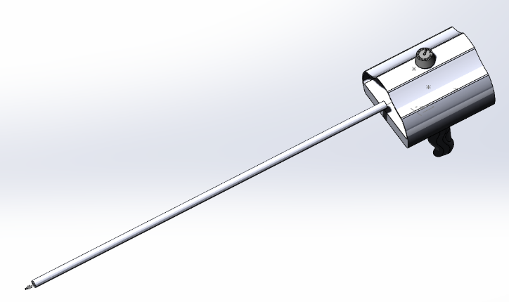
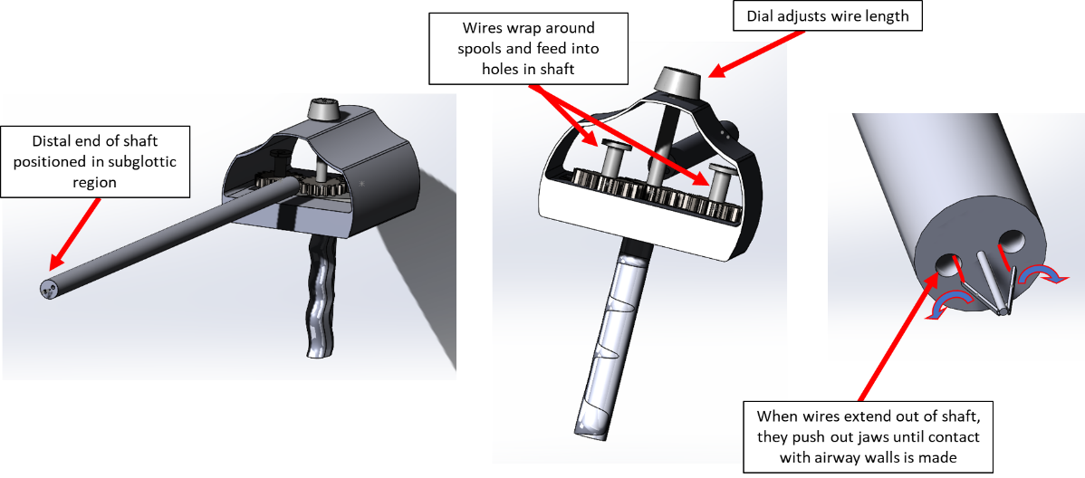

FORM REVISION HISTORY
REV | AUTHOR NAME | REVISION DESCRIPTION | REVISION DATE
0 | Isabella Koshoffer | Initial Release | 04/04/2022
1 | Isabella Koshoffer | Design Review 1 | 4/21/2022

REQUIRED | APPROVALS | DATE
Position Title | Signature
Author/ | Isabella Koshoffer | 4/21/2022
Quality Manager | Isabella Koshoffer | 4/21/2022

Product Requirements Specification
- REVISION HISTORY
Revision | Description | Author | Date
0 | Initial Release | Alex Madzia | 4/4/2022
1 | Design Review 1 | Alex Madzia | 4/21/2022

- APPROVALS
Representative | Signature | Date
Alex Madzia | Alex Madzia | 4/4/2022
Alex Madzia | Alex Madzia | 4/21/2022

- PURPOSE

This document’s purpose is to define the Product Requirement Specifications of the JIASize.

- SCOPE

The Product Requirement Specifications for the JIASize are included in this document.

- APPLICABLE STANDARDS
ISO 10993-1: 2018
ISO 10993-9: 2019
IEC 62366
ISO 11135:2014
FDA 21 CFR 801
ISO 13485

- INTRODUCTION
6.1 Definitions
Term / Acronym | Definition
ISO | International Standards Organization
IEC | International Electrotechnical Commission
EtO | Ethylene Oxide
FDA | Food and Drug Administration
CFR | Code of Federal Regulations
PMDA | Pharmaceutical and Medical Device Agency
SOR | Statutory Orders and Regulations
6.2 Conventions
In this document the following conventions are used for requirements:
Shall – used to indicate that a requirement is mandatory.
Should – used to indicate that a requirement is desirable, but not mandatory.
May – used to indicate alternatives or ways of potentially meeting a requirement or validating a requirement.
Product Requirements Specifications are numbered PRS-XXXX, where XXXX is a 4-digit sequential number.
7.0 DEVICE OVERVIEW
7.1 Device Description
The JIASize consists of a handle with a circular dial that is connected to a flexible shaft that is inserted into the airway. At the distal end of the shaft are two jaws that open and close when the dial on the handle is rotated. The dial is connected to gears that, when turned, feed out two wires from an internal spool. The distal ends of the wires are connected to the proximal ends of the jaws, so that as the wires are fed out from the spool, the jaws are pushed outward. The dial shall be rotated until the jaws expand to the point at which they make contact with the walls of the airway.
7.2 Intended Use/Indications for Use
The JIASize is intended to be used for pediatric airway sizing. It is intended for use in patients who are intubated with a laryngoscope and under general anesthesia. It shall be inserted through the mouth with the distal end of the device positioned axially in the subglottal region.
8.0 (DESIGN INPUT) PRODUCT REQUIREMENT SPECIFICATIONS

3.1 Performance and Reliability
DI No. | Title | Specification | Safety Related | Source/ Rationale | Verification Guidance
PRS-001 | Flexibility | Device must be able to pass around radius of 60mm without kinking | Yes | UN 1; Anatomical range | Bench Testing
PRS-002 | Biocompatibility | Materials must not cause immunogenic response | Yes | ISO 10993-1: 2018 | Animal Testing
PRS-003 | Jaw adjustment precision | Amount adjusted on knob must correspond to amount that jaws adjust ±0.25mm | No | UN 1 | Bench Testing
PRS-004 | Degradability | Device shall not break down or shed particulate inside body during use | Yes | ISO 10993-9: 2019 | Animal Testing
PRS-005 | Torque to Rotate dial | Torque to rotate dial must be <41.5 N*m to ensure usability | No | UN 3; IEC 62366 | Bench Testing

3.2 Functional and Physical Features
DI No. | Title | Specification | Safety Related | Source/ Rationale | Verification Guidance
PRS-006 | Jaw adjustment mechanism | Jaw adjustment mechanism must enable user to adjust jaws in maximum of 0.5mm increments | No | UN3 | Bench Testing
PRS-007 | Upper and Lower Measurement Limits | The distance between the outside edges of the jaws must be able to be adjusted from 2mm to 14mm | No | UN1 / Anatomical range | Bench Testing
PRS-008 | Shaft length | The distance from the distal end of the handle to the distal end of the shaft must be greater than or equal to 30cm | No | Anatomical range | Bench Testing
PRS- 009 | Handle diameter | Handle diameter shall be 1.5±0.25in | No | UN2 | Bench Testing
PRS-010 | Wire thickness | Wires shall be 0.5±0.05mm in diameter | No | UN3; UN6 | Component Inspection
PRS-011 | Wire length | Wires shall be >337.47mm | No | UN3; UN6 | Component Inspection
PRS-012 | Wire lumen diameter | Lumen for wires in shaft shall be 0.65±0.05mm in diameter | No | UN3; UN6 | Bench Testing

3.3 Interfaces/Interoperability with External Systems and Devices
DI No. | Title | Specification | Safety Related | Source/ Rationale | Verification Guidance
PRS-013 | Camera compatibility | Device shaft must be <4mm in diameter to allow for concurrent use with 12.5mm diameter camera positioned in subglottal space | No | UN 5 | Design Validation

3.7 Manufacturability
DI No. | Title | Specification | Safety Related | Source/ Rationale | Verification Guidance
PRS-014 | Cost to manufacture | Cost to manufacture must be less than $150 | No | UN 3; Upper end cost of 5 endoscopy tubes | BOM

3.6 Environment (Storage, Shipment, Operation)
DI No. | Title | Specification | Safety Related | Source/ Rationale | Verification Guidance
PRS-021 | Shelf life | Device must be functional for minimum of 5 years after manufacturing | Yes | Material degradation properties of PLA | Accelerated aging
PRS-022 | Temperature conditions | Device shall not be stored or transported in environments exceeding 85 degrees Celsius | Yes | Melting point of PVC | Temperature conditioning
PRS-023 | Container strength | Shipping and shelf box should protect device from falls of 20 ft | Yes | Potential height in truck | Simulated distribution testing
PRS-024 | Container compressive strength | Shipping and shelf box should without compressive loads of 200lbs without damaging device | Yes | Maximum stack height | Simulated distribution testing
3.9 Regulatory and Industry Standards
DI No. | Title | Specification | Safety Related | Source/ Rationale | Verification Guidance
PRS-015 | Device Classification | Meets FDA definition of a Class II Medical Device | No | Moderate-risk, non-implantable, non-life-sustaining | Regulatory justification
PRS-016 | Global Regulatory Compliance | In compliance with FDA 21 CFR, EU Medical Devices Directive, PMDA (Japan), and SOR 98/ 282 (Canada) | Yes | Market opportunity | Regulatory justification

3.5 Labeling, Customer Documentation and Packaging
DI No. | Title | Specification | Safety Related | Source/ Rationale | Verification Guidance
PRS-017 | Sterilization | Entire device must be permeable to EtO sterilization | Yes | ISO 11135:2014 | Bioburden testing
PRS-018 | Labeling – Date | The shelf box shall contain the date of manufacturing | Yes | FDA 21 CFR 801 | Attribute testing
PRS-019 | Labeling – Instructions | The shelf box shall contain the instructions for use | Yes | FDA 21 CFR 801 | Attribute testing
PRS-020 | Labeling – Identification | Each device shall be labeled with a unique, traceable serial number | Yes | FDA 21 CFR 801 | Attribute testing

Appendices
N/A

FORM REVISION HISTORY
REV | AUTHOR NAME | REVISION DESCRIPTION | REVISION DATE  (DD-MMM-YYYY)
0 | Alex Madzia | Design Review 1 | 04-21-2022

REQUIRED | APPROVALS | DATE
Position Title | Signature
Author/ | Isabella Koshoffer, Alex Madzia, Jocelyn Masters | 04-21-2022
Quality Manager | I | 04-21-2022

Engineering Calculations
Energy Flow Diagram
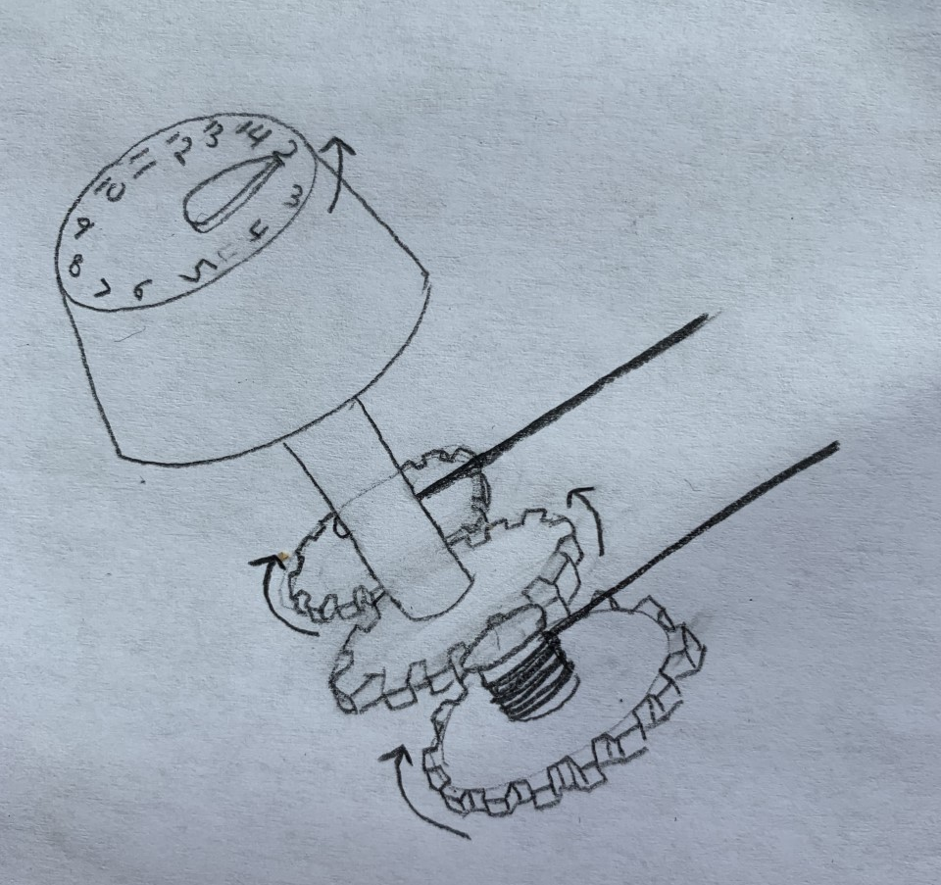
- The central gear’s counterclockwise rotation causes clockwise rotation of gears to its left and right
- Spools with wires wrapped around them are rigidly attached to the side gears, so that clockwise rotation of the side gears causes wire to be unraveled from the spool
- User applies rotational mechanical energy to dial to align pointer with desired jaw diameter (pointer is fixed)
- The dial is rigidly fixed to a central gear that rotates by the same amount as the dial
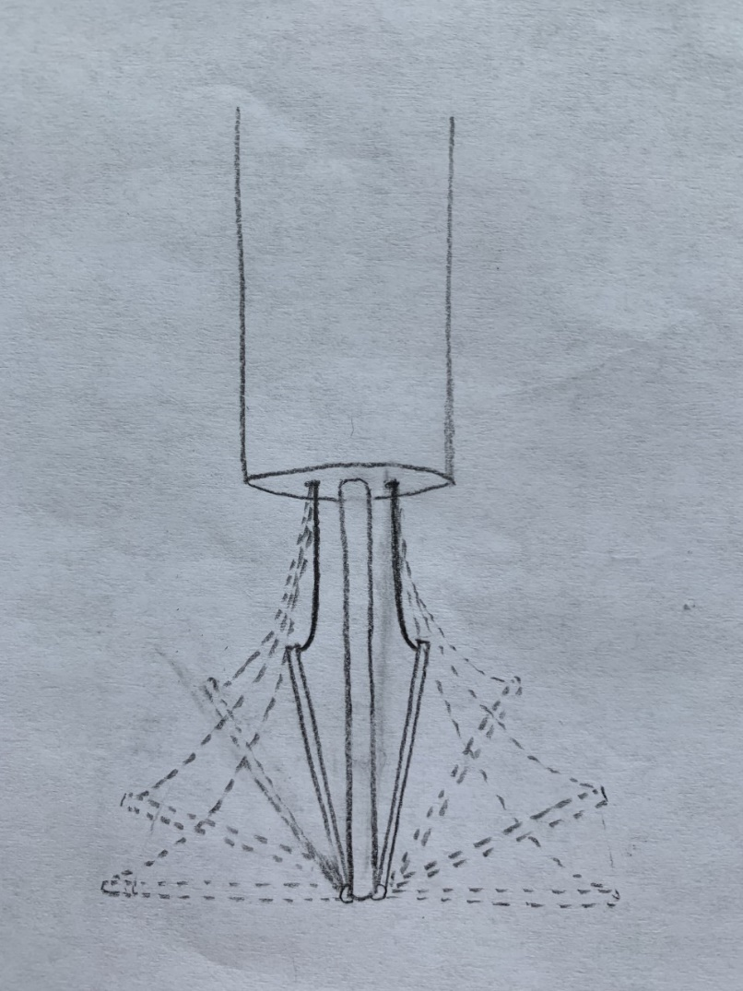
- Rotating the dial by 27.69° – resulting in the pointer being at the 3mm position – causes the wires to push out each jaw by 0.5mm (for 1mm total expansion)
- When the wire is fully raveled – meaning the dial is at the 2mm position – the jaws are 2mm apart

Calculations:
Dial Adjustment
360 degrees/13 (dial labeled from 2-14mm, creating 13 discrete arc segments) = 27.69 degrees/mm

Wire Unraveling/Jaw dimensions
When the wires are fully raveled, the jaws are 2mm apart from each other. If the central support between the jaws is 0.75mm thick, then the jaws form a right triangle with the support. The short leg is 0.625mm long, and the hypotenuse (the jaw) is 6.625mm. The jaws are 6.625mm so that when they are fully extended, the ends of the jaws are 14mm apart (maximum adult airway size)
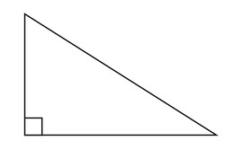
θ
6.625mm
0.625mm
Tanθ = .625/6.625 = 0.094°
This means that the jaws initially are 0.094° from the vertical. Each jaw must expand by a consistent amount of 0.5mm with each 27.69° adjustment of the dial until the jaws are 90° from the vertical. 90-0.094=89.906. Because there are 13 discrete mm segments, 89.906/13 = 6.916°. To increase the angle between the jaw and the vertical by 6.916° with each 1mm adjustment of the dial, enough wire must be unraveled to accomplish this. The amount of wire unraveled can be approximated as the change in length of the short leg of the right triangle.
0.094°+6.916°= 7.01°
7.01
X
6.625mm
Tan(7.01)=x/6.625
x = 0.815mm
Δx = 0.815 – 0.625 = 0.19mm
Using this approximation, an additional 0.19mm of wire must be unraveled from the spool to adjust each jaw by 0.5mm. This means that there must be 2.47mm of wire available to unravel. From PRSXXX, the length of the shaft must be greater than 30mm. Since the wire starts at the spool, which is slightly proximal to the shaft (~30mm), and ends at the jaws (~5mm), which are slightly distal to the shaft, then the total amount of wire should be at least 337.47mm (300mm+30mm+5mm+2.47mm).

Kink Radius
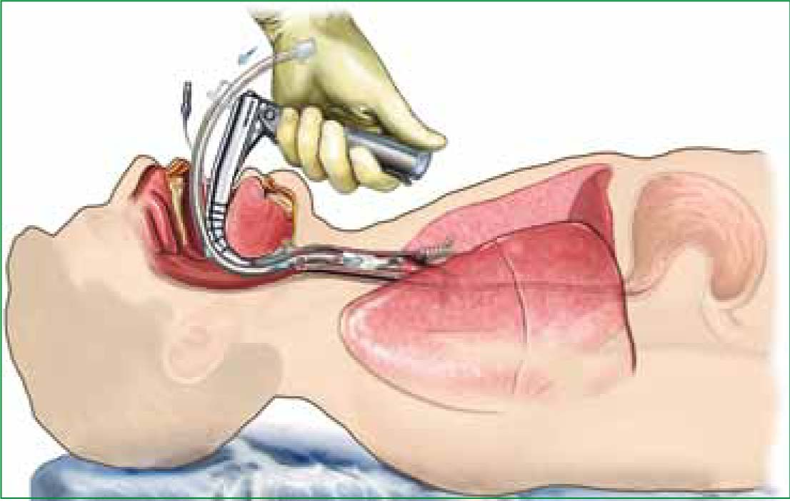
13mm
r=60mm
This graphic shows an intubated adult with an endotracheal tube inserted into the subglottis, the same region where JIASize will be inserted. Assuming the ET tube in this graphic is 13mm (standard adult ET tube diameter), then the radius of curvature formed by the laryngoscope and the wall of the back of the throat and airway is 60mm. This means that the shaft must be able to pass around a radius of curvature of at least 60mm without kinking to ensure proper wire extension.

Bending Strength
The shaft is intended to be made of Thermoplastic Co-polyester (TPC), which is known for its high elasticity and resistance to bending. According to 3D Materials By Armor, TPC can withstand 66MPA of bending force, which is well above what would be experienced in a worst case scenario in which the shaft was constrained to a 60mm radius of curvature.

Torque to Rotate Dial
The dial is intended to be rotated with one hand, meaning the torque to rotate should be <45N*m, which is the acceptable amount of force that a person of average strength can reasonably be expected to be able to exert. A 10% safety factor shall be added, giving a maximum acceptable force of 41.5N*m. The dial is a truncated cone, the volume formula for which is as follows:
volume = (1/3) * π * depth * (r² + r * R + R²)
volume = (1/3) * π * 25 * (40² + 40 * 50 + 50²)
volume = 109,694mm³ = 0.00011m³
Material: stainless steel
Stainless steel density: 8kg/m³
Mass of dial: 0.00088kg = 0.88g
Torque = r*F*sinθ
Torque = 45*(.88*9.8)*sin(90degrees)
Torque = 388N*mm = 0.388N*m
0.388 < 41.5

Detailed Engineering Drawings

Dial: Quantity - 1
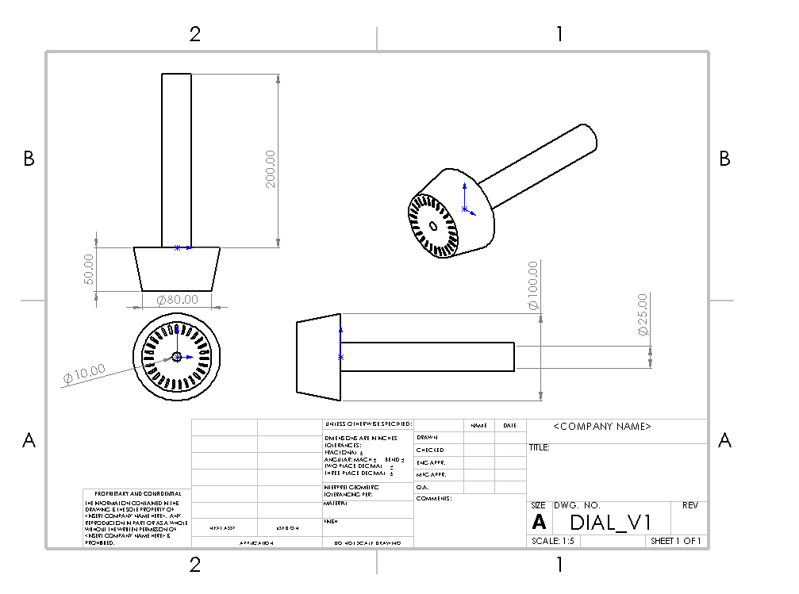
Gear: Quantity - 3
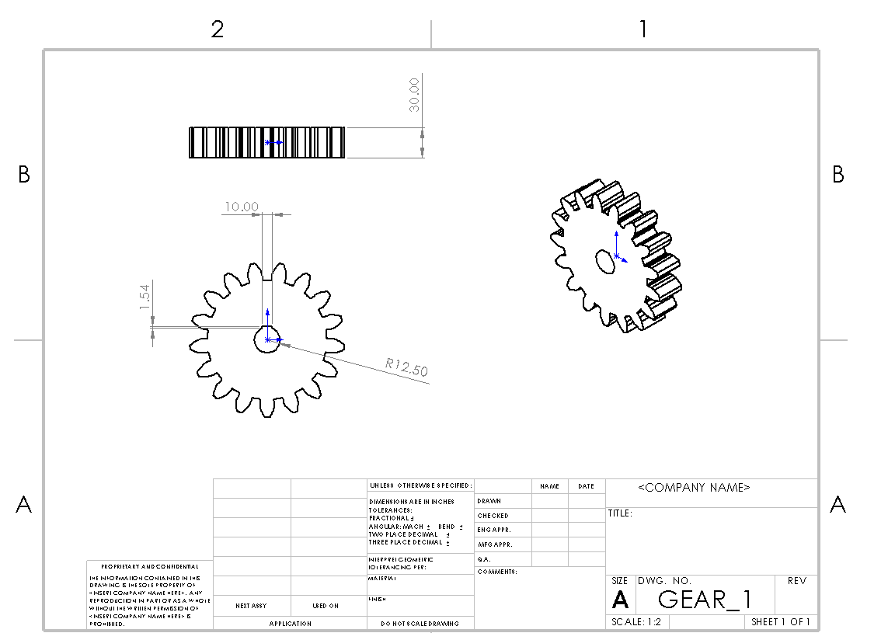
Gear Base: Quantity - 1
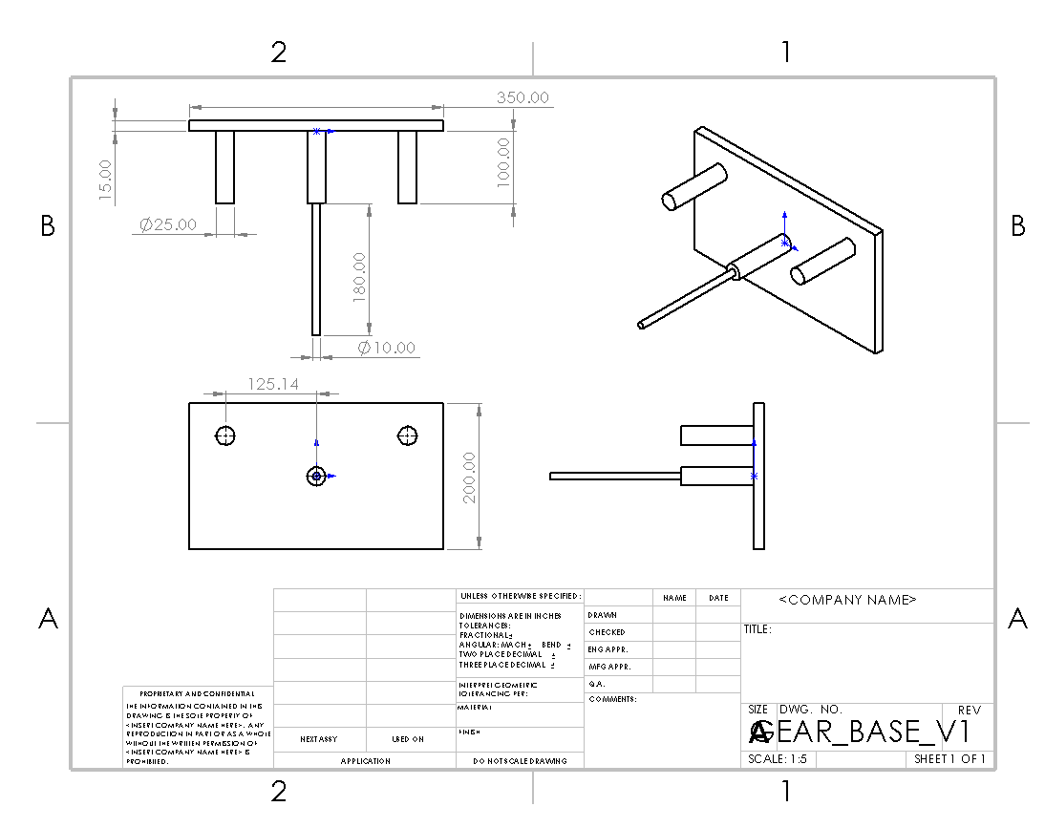

Pointer: Quantity - 1
Spool: Quantity - 2
Dial and Gear Assembly
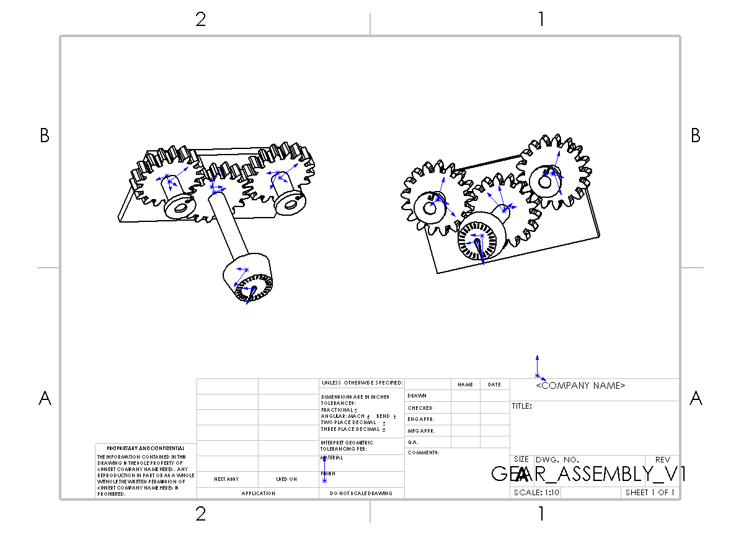
Handle: Quantity - 1
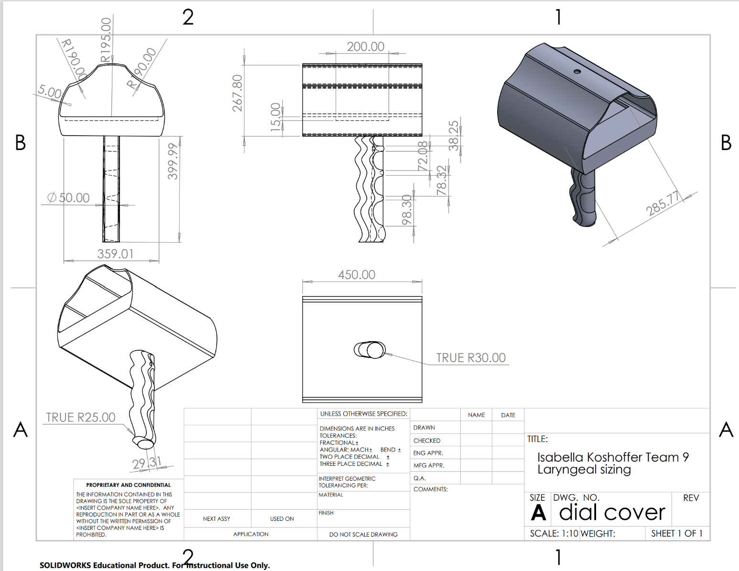
Shaft
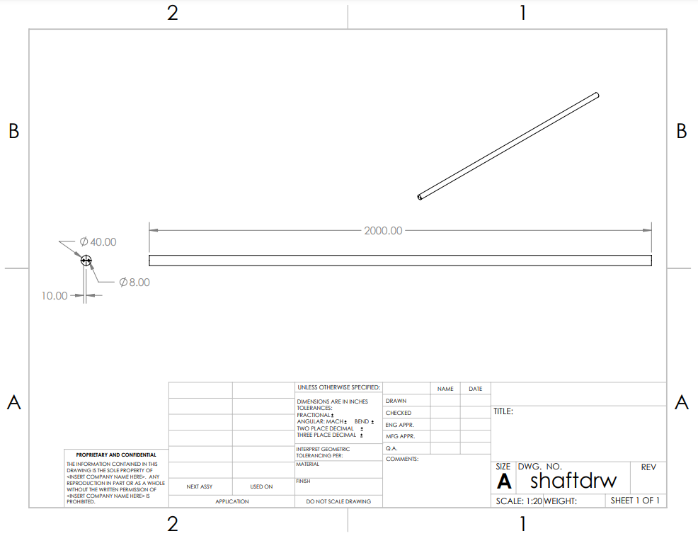
Jaw Assembly
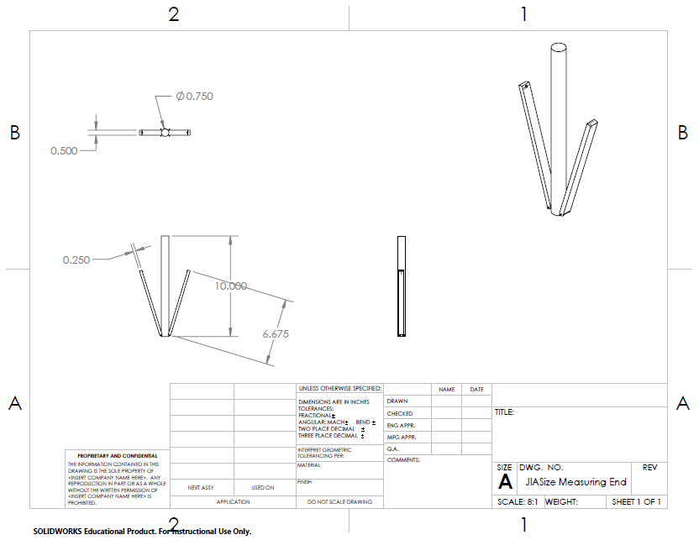

Full Assembly
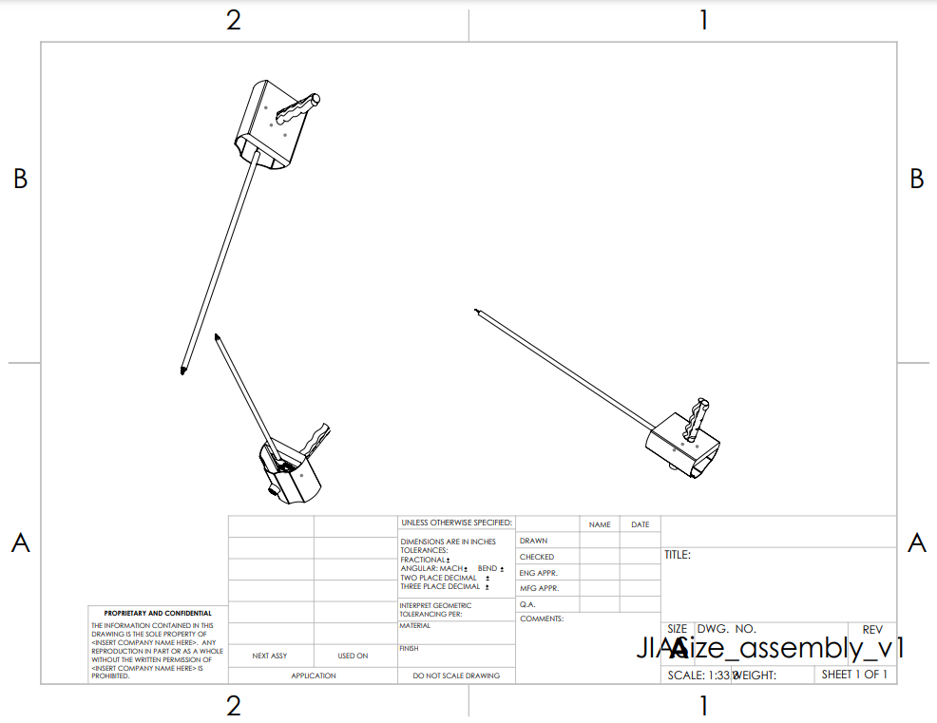

FORM REVISION HISTORY
REV | AUTHOR NAME | REVISION DESCRIPTION | REVISION DATE  (DD-MMM-YYYY)
1 | Alex Madzia, Isabella Koshoffer, Jocelyn Masters | Design Review 1 | 04/21/2022

REQUIRED | APPROVALS | DATE
Position Title | Signature
Author/ | Isabella Koshoffer, Alex Madzia, Jocelyn Masters | 04/21/2022
Quality Manager | Isabella Koshoffer | 04/21/2022

Bill of Materials
Assembly | Component | Current Material | Intended Material | Shelf Life | Intended Manufacturing Method | Estimated Material Cost ($) | Quantity
Jaws | Measurement jaws | PLA | PVC | N/A | Injection molding | 0.20 | 2
 | Hook Post | PLA | PVC | N/A | Injection molding | 0.10 | 2
 | Central Post | PLA | PVC | N/A | Injection Molding | 0.15 | 1
Shaft | Wires | 302 Stainless Steel | 302 Stainless Steel | 50 years | Machining | 16.00 | 2
 | Central Tube | PLA | TPC | 5 years | Injection molding | 0.43 | 1
Dial and Gears | Dial | PLA | 316 Stainless Steel | 50 years | Machining | 1.00 | 1
 | Gears | PLA | 316 Stainless Steel | 50 years | Machining | 5.00 | 3
 | Spool | PLA | 316 Stainless Steel | 50 years | Machining | 0.68 | 2
Handle | Grip | PLA | ABS | 5 years | Injection Molding | 1.50 | 1
 | Casing | PLA | ABS | 5 years | Injection Molding | 0.50 | 1

FORM REVISION HISTORY
REV | AUTHOR NAME | REVISION DESCRIPTION | REVISION DATE
0 | Isabella Koshoffer, Alex Madzia, Jocelyn Masters | Design Review 1 | 4/21/2022

REQUIRED | APPROVALS | DATE
Position Title | Signature
Author/ | Isabella Koshoffer, Alex Madzia, Jocelyn Masters | 4/21/2022
Quality Manager | Isabella Koshoffer | 4/21/2022

V&V Plan Traceability Matrix
 | Function | Requirement | Test Number | Test Name | Procedure | Acceptance Criteria
1 | Users need a way to safely measure the diameter of airway stenosis. | Device must be able to pass around radius of 60mm without kinking | 1 | Bench Testing | In vivo testing
 |  | Amount adjusted on knob must correspond to amount that jaws adjust ±0.25mm | 2 | Bench Testing | Measure with micrometer | ±0.25mm movement by jaws
 |  | Materials must not cause immunogenic response | 4 | Animal Testing | Given in ISO 10993-11 | Given in ISO 10993-11
 |  | Device shall not break down or shed particulate inside body during use | 5 | Animal Testing | Given in ISO 10993-11 | Given in ISO 10993-11
2 | Users need a comfortable, handheld device that fits a range of surgeons’ hand sizes. | Amount adjusted on knob must correspond to amount that jaws adjust ±0.25mm | 6 | Bench Testing | Measure with micrometer | ±0.25mm
3 | User needs a device that is simple and quickly measures the airway stenosis to streamline the procedure preparation. | Torque to rotate dial must be <41.5 N*m to ensure usability | 7 | Bench Testing | Complete torque testing | <41.5 N*m
 |  | Jaw adjustment mechanism must enable user to adjust jaws in maximum of 0.5mm increments | 8 | Bench Testing | Measure with micrometer | 0.5 mm increments
 |  | Wires shall be 0.5±0.05mm in diameter | 9 | Component Inspection | Measure with micrometer | 0.5±0.05mm diameter
 |  | Wires shall be >337.47mm | 10 | Component Inspection | Measure with micrometer | >337.47
 |  | Lumen for wires in shaft shall be 0.65±0.05mm in diameter | 11 | Bench Testing | Measure with micrometer | 0.65±0.05mm in diameter
 |  | Cost to manufacture must be less than $150 | 12 | BOM | Cost Analysis | $150 or less
4 | Users need a device that can be used in conjunction with a camera to enable a visual on the device’s location in the trachea to prevent further tissue damage. | Device shaft must be <4mm in diameter to allow for concurrent use with 12.5mm diameter camera positioned in subglottal space | 13 | Component Inspection and Bench Testing | Measure with micrometer | <4.00 mm in diameter
5 | Users need a small device that can be used to measure a range of stenosis severity grades in pediatric patients. | Device shaft must be <4mm in diameter to allow for concurrent use with 12.5mm diameter camera positioned in subglottal space | 14 | Component Inspection and Bench Testing | Measure with micrometer | <4.00 mm in diameter
6 | Users need a device that is calibrated to give accurate measurements of the airway stenosis severity. | Wires shall be 0.5±0.05mm in diameter | 15 | Component Inspection | Measure with micrometer | 0.5±0.05mm
 |  | Wires shall be >337.47mm | 16 | Component Inspection | Measure with micrometer | >337.47mm
 |  | Lumen for wires in shaft shall be 0.65±0.05mm in diameter | 17 | Bench Testing | Measure with micrometer | 0.65±0.05mm
7 | Users need a visual indication on the device to display the measurement of the airway stenosis once measured by the device. | Torque to rotate dial must be <41.5 N*m to ensure usability | 18 | Bench Testing | Complete torque test | <41.5 N*m
FORM REVISION HISTORY
REV | AUTHOR NAME | REVISION DESCRIPTION | REVISION DATE  (DD-MMM-YYYY)
0 | Isabella Koshoffer | Design Review 1 | 04-21-2022

REQUIRED | APPROVALS | DATE
Position Title | Signature
Author/ | Isabella Koshoffer, Alex Madzia, Jocelyn Masters | 04-21-2022
Quality Manager | Isabella Koshoffer | 04-21-2022

References
Airway anatomy [functions, child vs. Adult, Pictures &amp; More]. Rejuvenation Dentistry. (2021, January 21). Retrieved March 27, 2022, from https://www.rejuvdentist.com/sleep-apnea/airway-anatomy/
Airway stenosis. Riley Children's Health. (n.d.). Retrieved April 21, 2022, from https://www.rileychildrens.org/health-info/airway-stenosis
Armor 3D. (2019, February 19). TPC 91A. KIMYA. Retrieved April 21, 2022, from https://marketplace.createeducation.com/wp-content/uploads/2020/09/Safety_Document_TPC_91A_022019_EN.pdf
Chan, W.-H., Sung, C.-W., Chang, H. C.-H., Ko, P. C.-I., Huang, E. P.-C., Lien, W.-C., & Huang, C.-H. (2020, June 24). Measurement of subglottic diameter and distance to pre-epiglottic space among Chinese adults. PLOS ONE. Retrieved April 21, 2022, from https://journals.plos.org/plosone/article?id=10.1371%2Fjournal.pone.0236364
Giriraj K. Sharma, M. D. (2015, April 1). Device for measuring subglottic stenosis in 3-D. JAMA Otolaryngology–Head & Neck Surgery. Retrieved April 21, 2022, from https://jamanetwork.com/journals/jamaotolaryngology/fullarticle/2119040
Glottic cancer ‣ anatomy. THANC Guide ‣ Knowledge. Hope. Support. (2021, October 8). Retrieved March 27, 2022, from https://thancguide.org/cancer-types/throat/laryngeal/glottic/anatomy/
Mayo Clinic. (2019, January 8). Multidisciplinary care of idiopathic subglottic stenosis - mayo clinic. Mayo Clinic. Retrieved April 21, 2022, from https://www.mayoclinic.org/medical-professionals/pulmonary-medicine/news/multidisciplinary-care-of-idiopathic-subglottic-stenosis/mac-20451594
Nasser, H. M., Askoura, A., & Hussein, A. (2020, November 4). Ultrasonography diagnostic validity in structural and functional laryngeal disorders - egyptian Journal of Radiology and Nuclear Medicine. SpringerOpen. Retrieved April 21, 2022, from https://ejrnm.springeropen.com/articles/10.1186/s43055-020-00334-8
Shelf-life storage of medical grade thermoplastic polyurethane elastomers - lubrizol. Lubrizol Life Science. (2020, June 15). Retrieved April 21, 2022, from https://www.lubrizol.com/-/media/Lubrizol/Health/Literature/Shelf-Life-Document-for-Medical-Grade-TPU---Final.pdf

